CS 558 Assignment 5

Jieru Hu

Analysis

**Overview**

In this assignment, we construct a piecewise linear approximation for the shape, represented by a given implicit representation. Then we answer four questions about the information on the shape.

**Analysis**

1. We use marching squares to reconstruct the piecewise linear approximation of the shape S. h is an input parameter, such that each piece of the approximation should not be longer than h. We assume the domain and range of our function are both [-50*h,50*h]. We divide the whole region into squares side length of h. Therefore, there should be 100*100 squares in this region. A 2D array is used to store all the squares as well as the information related to them. We create a box object, with several fields:

1 The coordinates of four corner points

2 Piecewise line segment which is defined with in the square

Once we have coordinates (x,y) of all the points in the square, we could evaluate the objective value of f(x,y) for all corner points. If the objective value is larger or equal than zero, we mark the point as positive, else we mark the point as negative. Then we have 16 different possibilities squares, as following:

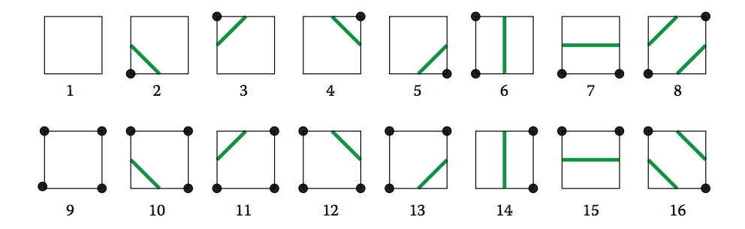

For each square stored in the 2D array, we test which case the square belongs to so that we could get an expression for the line segment (using two endpoints) within the square. Once we finish testing on all squares, we could get the all linear pieces for the approximation.

For the animation, we use turtle to draw all the piece wise shapes.

2.

Q1: We count the number of the line segments in each square and add them up to get the number of connected components.

Q2: To determine of the S is simply connected, we use the similar test method used in the simple polygon. First, we test if each points appear exactly twice in all linear segments. Then we test if the linear approximation contains a hole. We begin with a random point and start traversing through all the points in the piecewise boundary. If all the points are visited after we complete the traverse, we are fine. At last, we check if there is intersection within the boundary. Each pair of the linear piece is check by cross product.